XRSound GUI

XRSound GUI is a graphical interface to configure XRSound. Instead of opening the configuration file in a text editor, edit the values directly from this lightweight interface.

How to use

Simply open XRSound GUI.exe file from the program folder. If that’s your first one, a dialog will appear to set Orbiter folder:

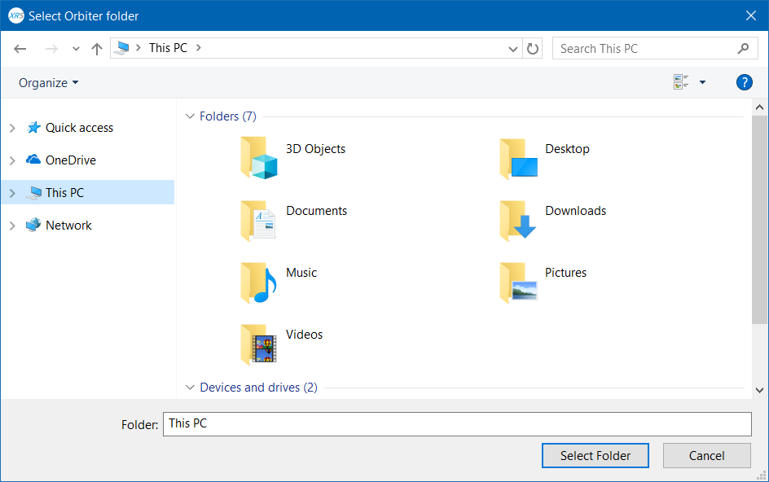

Select Orbiter folder (Where Orbiter.exe file exists) and hit ‘Select Folder’ button.

If the folder is correct and XRSound is installed, the main interface will appear:

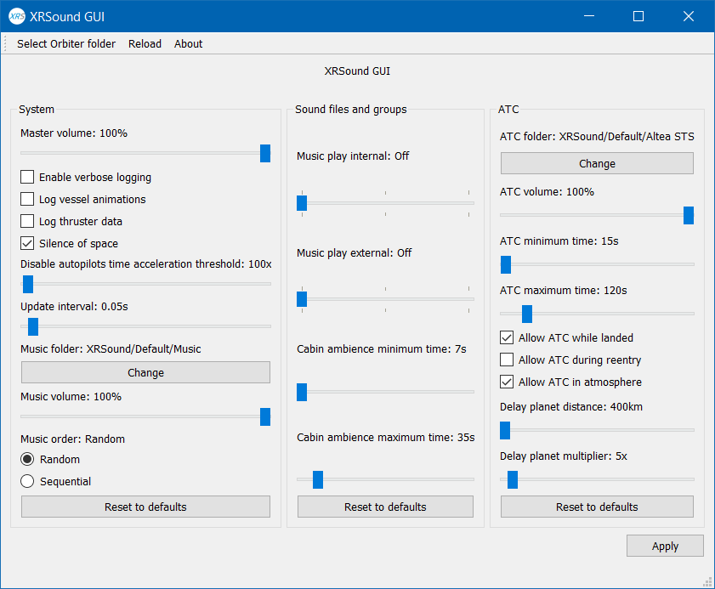

The interface will appear disabled if the selected folder was wrong, or XRSound isn’t installed.

Start editing the options as you like. You can find a reference below with explanation to each option. After finishing, **you must hit ‘Apply’ button** to save your changes, otherwise, you’ll lose changes when closing the program without clicking on ‘Apply’ button.

You can find a reset button below each group. You can use it to reset the group options to their defaults values. You must also press ‘Apply’ button to save changes.

To change the music or ATC folder, press ‘Change’ button. A folder chooser dialog will appear. Select the folder you want and press ‘Select Folder’. Note that the folder must be inside Orbiter folder. If the folder was outside, a warning message will appear.

To reload the configuration file without restarting the program, you can press ‘Reload’ button in the menu bar. Note that your changes will be lost after re-loading the configuration file.

Currently, sound files and groups section isn’t implemented.

About

XRSound GUI is a lightweight graphical interface to configure XRSound. It’s open source under GPL 3 license. You can find the source code on [GitHub](https://github.com/abdullah-radwan/XRSound-GUI).

**Note**: This tool **isn’t an official XRSound tool, and it’s not provided nor maintained by XRSound team.** If you need help, please don’t contact XRSound team. Instead, contact me below.

Copyright © Abdullah Radwan

Email: [abbodmar@gmail.com](mailto:abbodmar@gmail.com?subject=XRSound%20GUI)

Reference

Master volume

Set the master volume for all sounds. Range is 0 (silent) - 100 (max, default).

Enables verbose logging

Enables verbose logging to XRSound.log. Useful for debugging your XRSound enabled vessel.

WARNING: this setting is intended for development / debugging, and can cause the log file to grow very quickly depending on what the vessels in the simulation do.

Options:

Unchecked = disabled (default).

Checked = enabled.

Log vessel animations

Enables logging of vessel animation states, useful for determining which animation ID is used by a given animated mesh on a vessel.

Options:

Unchecked = disabled (default).

Checked = enabled.

Log thruster data

Enables logging of vessel thruster indexes and levels, useful for determining which custom thrusters are SCRAM engines, for example.

WARNING: this setting is intended for development / debugging, and can cause the log file to grow very quickly depending on what the vessels in the simulation do.

Options:

Unchecked = disabled (default).

Checked = enabled.

Silence of space

Enables the "Silence of Space" realism feature that fades sounds via falling static pressure as you leave the atmosphere, i.e., in a vacuum, you will not hear any sounds outside your ship.

Options:

Unchecked = disabled.

Checked = enabled (default).

Disable autopilots time acceleration threshold

Automatically disables the default autopilots when time acceleration exceeds this threshold. The default is 100 (meaning, 100x), since some systems can handle 100x or more time acceleration running the D3D9 client at getting several hundred frames-per-second. If your vessels are not stable using the default autopilots at 100x time acceleration, lower this setting.

Note: this feature can only affect Orbiter's *default* autopilots, not any *custom* autopilots implemented by vessels or MFDs.

Valid range is 0 (disabled) - 10000. The default value is 100.

Update Interval

Sets the refresh interval, in fraction of a second, for sound updates, the smaller the value, the more often XRSound updates the state of its sounds.

XRSound has low system overhead, and so normally you should not need to change this setting. However, if you want to experiment with increasing or decreasing how many times per second XRSound updates its sound states, change this setting and relaunch an Orbiter scenario. You do not need to exit Orbiter and restart it.

Valid range is 0.02 (50 updates per second) - 1.0 (1 update per second).

The default value is 0.05 (20 updates per second).

Music folder, volume, and order

Global music settings. Sound files in the specified music folder may be played back at random or sequentially. Unlike other sounds and sound groups, music sounds play independently of any vessel, except that the active vessel determines whether the music keeps playing or paused at any given instant. See the Music play internal and Music play external settings in this file for details.

Defaults:

Music folder = XRSound/Default/Music [none = disable music, e.g. Music folder = none]

Music volume = 100% [range is between 0% (muted) and 100% (max)]

Music order = Random [may be sequential or random]

Music play internal and external

Vessel-specific music settings. By default, plays only in external view in space (vacuum). Refer the global (i.e., vessel-independent) music settings above for more information.

Options:

Music play internal = Off [sets whether music plays in internal view. Values are Off (default), Space, or On]

Music play external = Space [sets whether music plays in external view. Values are Off, Space (default), or On]

Cabin ambiance minimum and maximum time

Minimum and maximum times between cabin ambiance sounds playing. Values are in seconds. Valid ranges are 7 - 300, and Cabin ambiance maximum time must be >= Cabin ambiance minimum time.

Defaults:

Cabin ambience minimum time = 7s.

Cabin ambience maximum time = 35s.

ATC folder

ATC files folder. Files in this folder play at random intervals as configured via other ATC settings. If set to 'none', ATC is disabled.

Default = XRSound/Default/Altea STS

ATC volume

Sets the volume for ATC callouts. Range is 0% (silent) – 100% (max, default).

ATC minimum and maximum time

Minimum and maximum times between ATC sounds playing. Values are in seconds. Valid ranges are 10 - 900, and ATC maximum time must be >= ATC minimum time.

Defaults:

ATC minimum time = 15s.

ATC maximum time = 120s.

Allow ATC while landed

Allows ATC while landed.

Options:

Unchecked = disabled.

Checked = enabled (default).

Allow ATC during reentry

Allows ATC during reentry.

Options:

Unchecked = disabled (default).

Checked = enabled.

Allow ATC in atmosphere

Allows ATC while in an atmosphere.

Options:

Unchecked = disabled.

Checked = enabled (default).

Delay planet distance

Delay ATC by Delay planet multiplier times when more than this many km away from a planetary body.

Minimum = 0 km (no delay)

Maximum = 1e6 km (one million Km)

Default = 400

Delay planet multiplier

Delay ATC by this many times when more than Delay planet distance km away from a planetary body.

Min = 1x (no extra delay)

Max = 100x

Default = 5x